1. Statistical analysis for change over time:
2. Life satisfaction
3. posMINUSnegaffect
4. Personal Growth
5. Purpose in life
6. Self Acceptance

From Q1-Q4, Q2-Q4, Q3-Q4, Q2-Q1, Q2-Q3 are significantly increase

From Q1-Q2, Q3-Q2, Q4-Q2, Q4-Q1, Q4-Q3 are significantly decrease

From Q1-Q3, Q3-Q1, those changes are not significant.

1. Portion analysis towards communion:

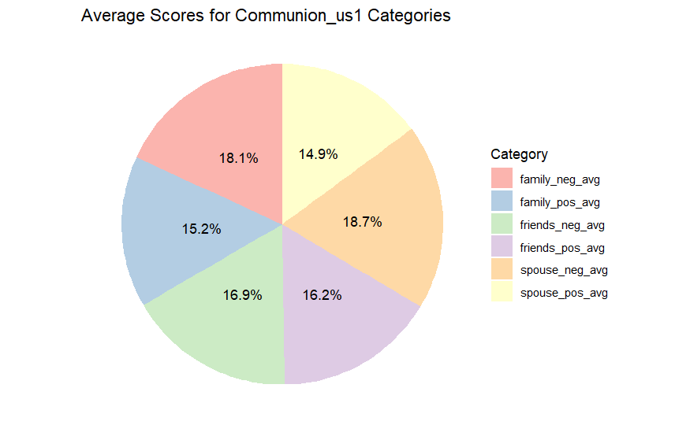

For us2 data:

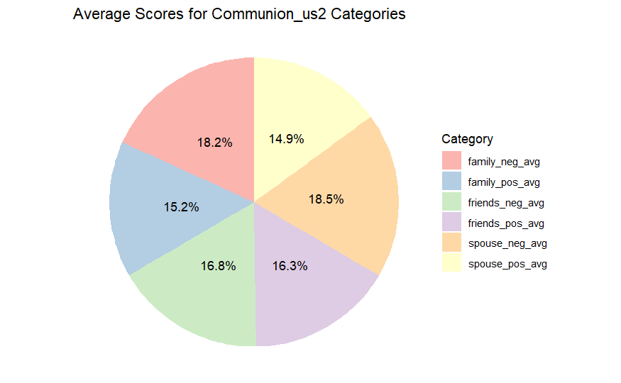

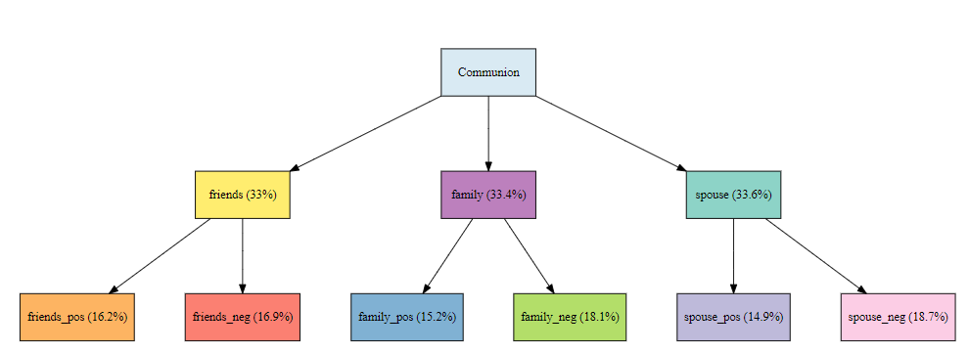

For us2 data:

